Passive Quarter Car Suspension Analysis
Vehicle ride coursework | Module 7ENT2056
Abdul Barek | SRN 23103907
University of Hertfordshire | MSc Automotive Engineering

Abstract
This report evaluates a passive quarter-car suspension using the parameters assigned to SRN 23103907. Newton’s law gives a coupled two-degree-of-freedom model, with natural frequencies of 1.157 and 10.680 Hz. Free vibration and a 30 mm road bump are simulated. A constrained parameter sweep reduces body RMS displacement by 21.4% for a 0.5 s bump through lower spring stiffness and higher damping. However, acceleration increases for a shorter bump. The proposed change therefore requires validation across road conditions, available suspension travel and static loading before practical adoption.

Introduction
A suspension must support the vehicle while limiting the motion transmitted from the road. The sprung mass represents the supported body at one wheel; the unsprung mass represents the wheel and associated components. The suspension spring stores energy, the damper dissipates it, and tyre stiffness and damping govern the connection to the road. A quarter-car model captures their vertical interaction without the complexity of whole-vehicle pitch and roll.
Mudduluru and Chizari (2021) use quarter- and full-car models to balance comfort and road holding through parameter optimisation. Abd-Elwahab et al. (2024) compare optimisation methods for passive spring, damper and tyre parameters, showing why a baseline comparison matters. Nagarkar et al. (2024) extend the assessment to weighted acceleration and experimental testing. Their work supports evaluating suspension and tyre deflection alongside body motion. Ozcan et al. (2023) investigate nonlinear spring and damper characteristics, highlighting a limitation of constant-coefficient models. He et al. (2023) demonstrate experimentally that suspension layout and actuator imperfections also affect design trade-offs; their active system is beyond the scope of the present passive model.
The aim is to derive and solve the assigned model, identify its vibration modes, plot road and mass motion, and assess parameter changes that reduce body travel. The analysis distinguishes absolute body displacement from relative suspension travel. Acceleration and dynamic tyre load provide additional checks, because a smaller displacement alone does not establish improved ride comfort or road holding.

1 Model data and force definitions
Table 1 reproduces only the row for SRN 23103907 in the supplied class list (University of Hertfordshire, 2025b). All displacements are measured upward from the original static equilibrium.
Parameter | Meaning | Assigned value
Ms | Sprung mass | 303.3 kg
Mu | Unsprung mass | 43.7 kg
ks | Suspension stiffness | 17,628.6 N/m
kt | Tyre stiffness | 178,932.3 N/m
cs | Suspension damping | 1,311.7 Ns/m
ct | Tyre damping | 5.2 Ns/m
Xs | Body displacement | 0.029 m
Xu | Wheel displacement | 0.022 m
xr | Road displacement scale | 0.030 m
The assigned Xs and Xu are taken as initial displacements for the free and combined-response cases. Initial velocities are assumed zero. The assigned road value is interpreted as bump height. Its timing and duration are modelling choices, rather than additional class-list data.
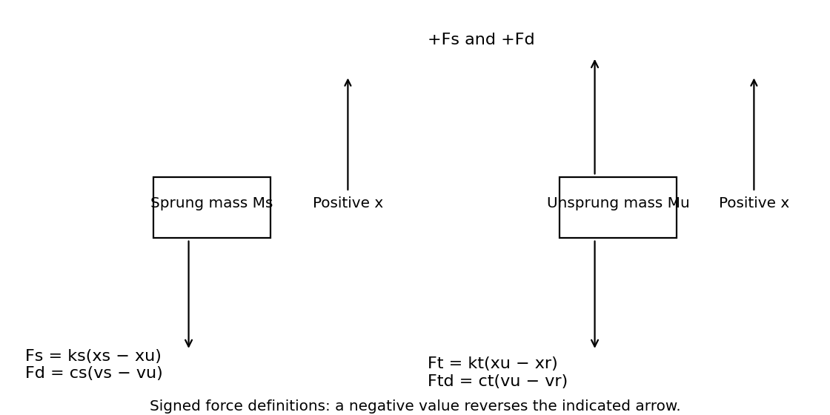
Figure 1. Original dynamic free-body diagrams. The two suspension forces share a downward arrow on Ms and an equal opposite upward arrow on Mu.
Let Fs = ks(xs − xu), Fd = cs(vs − vu), Ft = kt(xu − xr), and Ftd = ct(vu − vr). These are signed components. Their sum acts downward on the body and upward on the wheel for the suspension, while tyre components act downward on the wheel. A negative component reverses its arrow. No independent actuator or applied dynamic force is included.

2 Equations of motion

2 1 Static loading and dynamic balance
At static equilibrium, the suspension supports Ms g = 2,975.373 N and the tyre supports (Ms + Mu)g = 3,404.070 N, using g = 9.81 m/s². The associated direct vertical spring deflections are 0.16878 m and 0.01902 m. These equilibrium forces balance gravity before the dynamic coordinates are introduced. Gravity is therefore absent from the incremental equations, rather than physically absent from the vehicle.
Ms ẍs = −ks(xs − xu) − cs(ẋs − ẋu) (1)
Mu ẍu = ks(xs − xu) + cs(ẋs − ẋu) − kt(xu − xr) − ct(ẋu − ẋr) (2)
Equation (1) follows from the body forces in Figure 1. Equation (2) combines the equal and opposite suspension force with both tyre forces. Relative deformation determines spring loading; relative velocity determines damping. The tyre dashpot requires road velocity as well as road displacement.

2 2 Matrix form and individual coefficients
M q̈ + C q̇ + K q = [0, kt xr + ct ẋr]ᵀ, q = [xs, xu]ᵀ (3)
M = [[303.3, 0], [0, 43.7]] kg
C = [[1311.7, −1311.7], [−1311.7, 1316.9]] Ns/m
K = [[17628.6, −17628.6], [−17628.6, 196560.9]] N/m
303.3 ẍs + 1311.7 ẋs − 1311.7 ẋu + 17628.6 xs − 17628.6 xu = 0
43.7 ẍu − 1311.7 ẋs + 1316.9 ẋu − 17628.6 xs + 196560.9 xu
= 178932.3 xr + 5.2 ẋr
The matrices are symmetric. M is positive definite, K is positive definite, and both damping coefficients are positive. These properties are consistent with a stable passive system. The model assumes rigid masses, linear elements, fixed coefficients, direct vertical motion and continuous tyre contact. It excludes bump stops, suspension geometry, friction, pitch, roll and lateral motion.

3 Natural frequencies and vibration modes
For undamped free vibration, set xr = 0 and C = 0, then seek q = φ exp(iωt). A nonzero mode requires det(K − ω²M) = 0. Expanding the determinant gives the complete parametric solution:
(ks − Msω²)(ks + kt − Muω²) − ks² = 0
MsMuω⁴ − [ksMu + Ms(ks + kt)]ω² + kskt = 0
Let λ = ω², a = MsMu, b = ksMu + Ms(ks + kt), and c = kskt. The two roots are λ₁,₂ = [b ∓ √(b² − 4ac)]/(2a). For the individual values:
13254.21000 λ² − 60387290.79000 λ + 3154325943.78000 = 0
λ₁ = 52.847936 s⁻²; λ₂ = 4503.235813 s⁻²
Mode | ωn rad/s | fn Hz | [xs xu] with xs = 1
Body dominated | 7.269659 | 1.157002 | [1, 0.090751]
Wheel hop | 67.106153 | 10.680276 | [1, −76.478156]
Mode shapes follow from (ks − Msλ)φs − ksφu = 0, hence φu/φs = (ks − Msλ)/ks. In the first mode, the body and wheel move in phase and body motion dominates. In the second, they move in opposite directions and wheel motion dominates. Both masses participate in both modes; assigning one independent natural frequency to each mass is only an approximation.

3 1 Approximate checks
fbody ≈ √(ks/Ms)/(2π) = 1.2134 Hz
fwheel ≈ √[(ks + kt)/Mu]/(2π) = 10.6740 Hz
The body approximation neglects wheel compliance, while the wheel approximation fixes the body. The coupled result is used throughout the report. With damping restored, the state-matrix poles are:
s = −1.827521 ± 7.132589i; s = −15.402365 ± 64.440354i s⁻¹
The corresponding damped oscillation frequencies are 1.1352 and 10.2560 Hz, approximately. Pole damping ratios, calculated as −Re(s)/|s|, are 0.2482 and 0.2325. These are obtained from the full damped model; the damping matrix is not assumed to be proportional.

4 System response and numerical method

4 1 State solution
Using z = [xs, xu, ẋs, ẋu]ᵀ, Equation (3) becomes ż = Az + b(t), where the lower blocks of A are −M⁻¹K and −M⁻¹C.
A = [[0, 0, 1, 0],
[0, 0, 0, 1],
[−58.122651, 58.122651, −4.324761, 4.324761],
[403.400458, −4497.961098, 30.016018, −30.135011]]
b(t) = [0, 0, 0, (178932.3 xr + 5.2 ẋr)/43.7]ᵀ
z(t) = exp(At)z(0) + ∫₀ᵗ exp[A(t − τ)]b(τ)dτ (4)
The first term is the initial-condition response; the integral is the response to the road. This separation explains why an initial offset can reinforce or partially cancel the bump response. For an undamped free case, q(t) = Φ diag[cos(ω₁t), cos(ω₂t)] Φ⁻¹q(0), when initial velocities are zero.

4 2 Transfer functions
For zero initial conditions, let D(s) = (Ms s² + cs s + ks)[Mu s² + (cs + ct)s + ks + kt] − (cs s + ks)². Laplace transformation of Equations (1) and (2) gives:
Xs(s)/Xr(s) = (cs s + ks)(ct s + kt)/D(s) (5)
Xu(s)/Xr(s) = (Ms s² + cs s + ks)(ct s + kt)/D(s) (6)
Both displacement gains equal one at s = 0: on a slowly changing road, both masses follow its height. The common denominator contains the coupled system poles. Body acceleration is obtained directly from Equation (1), avoiding numerical differentiation of displacement.

4 3 Integration and verification
The numerical reference uses adaptive Runge–Kutta integration in Python SciPy over 0–8 s. Relative tolerance is 10⁻⁸, absolute tolerance 10⁻¹⁰ and maximum internal step 0.01 s, with output sampled every 0.001 s. The supplied MATLAB script implements the same equations using ode45 and the same settings. MATLAB was not available in this workspace, so the graphs are reference calculations, not claimed MATLAB execution results.
Tightening tolerances to 10⁻¹⁰ and 10⁻¹² changes the largest sampled state component by 5.61e-09 in its respective SI unit. Static gain, initial acceleration, matrix symmetry and decay of free-response energy provide further checks. No experimental validation is claimed.

5 Free vibration from the assigned offsets
The unforced case uses xr = 0, xs(0) = 0.029 m, xu(0) = 0.022 m, and zero initial velocities. Initial suspension extension is 0.007 m, giving Fs(0) = 123.4002 N. Initial incremental tyre force is 3,936.5106 N. Thus:
ẍs(0) = −123.4002/303.3 = −0.406859 m/s²
ẍu(0) = (123.4002 − 3936.5106)/43.7 = −87.256531 m/s²
The large initial wheel acceleration arises from releasing the prescribed wheel offset against a stiff tyre. It represents this mathematical release condition and should not be treated as a measured wheel acceleration on a normal road.
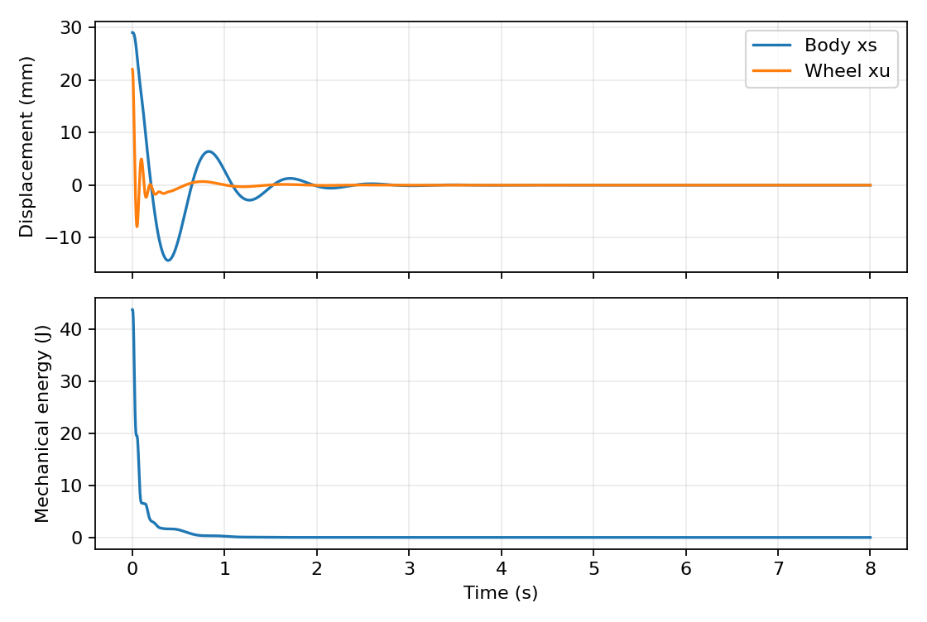
Figure 2. Free response and total incremental mechanical energy for the assigned offsets.
The body moves from 29.000 mm to a first negative extreme of approximately −14.319 mm; the wheel range is −7.907 to 22.000 mm. A short wheel-hop transient decays rapidly, while the slower body mode remains visible for longer. These different time scales agree with the two modal frequencies.
E = ½q̇ᵀM q̇ + ½qᵀKq; Ė = −cs(ẋs − ẋu)² − ct ẋu² ≤ 0
Initial energy is 43.7335 J and falls to approximately 1.85 × 10⁻¹² J at 8 s. Energy decay supports the force signs and passive damping implementation. Relative suspension travel remains distinct from either mass displacement.

6 Road profile and combined mass travel
A finite smooth bump avoids the impulsive tyre-damper force produced by an ideal road step. The assumed start is t₀ = 1 s and duration T = 0.5 s. With h = 0.030 m, the road profile is:
xr(t) = h/2{1 − cos[2π(t − t₀)/T]}, t₀ ≤ t ≤ t₀ + T; zero otherwise
ẋr(t) = hπ/T sin[2π(t − t₀)/T], within the bump; zero otherwise
Road height peaks at 30 mm at 1.25 s. Road velocity is continuous and zero at both ends. The maximum magnitude of road velocity is 0.18850 m/s. No vehicle speed or spatial bump length is inferred from the class list.
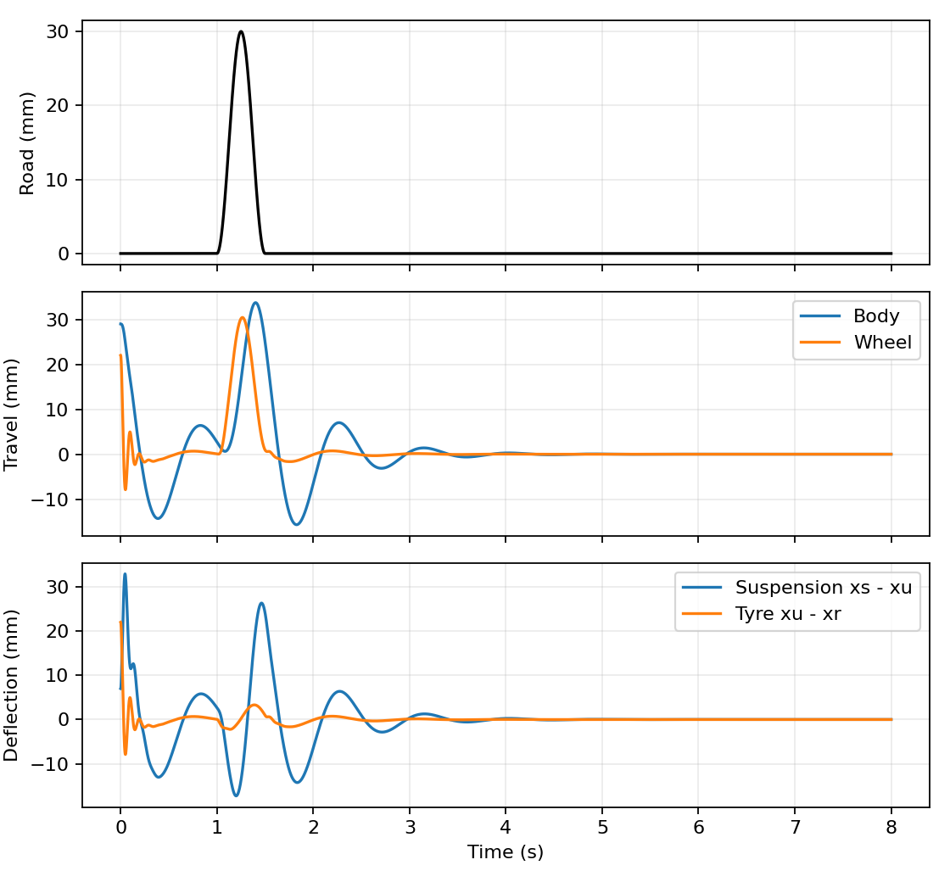
Figure 3. Road profile, body and wheel displacements, and relative element deflections with the assigned initial offsets.
The wheel follows the road more closely than the body, while the body response is delayed and continues after the bump. Over 1–8 s, peak absolute body displacement is 33.739 mm, wheel displacement is 30.442 mm, and relative suspension travel is 26.336 mm. The body may exceed road height because its response includes resonant and initial-condition contributions.
Uniform loading is represented through the equivalent lumped masses and linear elements. No additional unknown external force is introduced. The initial transient is retained here to use the assigned offsets explicitly; the following design comparison starts from rest to isolate the suspension’s road response.

7 Performance measures and design comparison
A zero-initial-condition bump case provides a fair basis for changing the design: otherwise the imposed initial body displacement would place a fixed lower bound on the peak. Road height, duration, masses and simulation settings remain the same for every candidate. All tabulated RMS measures use the interval 1–8 s, including the decay after the bump.
RMS(y) = √{[1/(8 − 1)] ∫₁⁸ y(t)²dt}
Suspension travel δs = xs − xu; tyre deflection δt = xu − xr
ΔFz = kt(xr − xu) + ct(ẋr − ẋu)
ΔFz is the upward incremental tyre force on the wheel. Road contact is checked with Fz = (Ms + Mu)g + ΔFz. Acceleration RMS is unweighted; it is a comparison metric, not an ISO comfort classification.
Measure over 1 to 8 s | Baseline | Modified | Change
Peak body displacement | 35.570 mm | 31.652 mm | −11.0%
RMS body displacement | 7.148 mm | 5.618 mm | −21.4%
RMS body acceleration | 0.3802 m/s² | 0.3390 m/s² | −10.8%
Peak body acceleration | 2.0222 m/s² | 2.0077 m/s² | −0.7%
Peak suspension travel | 27.251 mm | 19.629 mm | −28.0%
Peak absolute dynamic tyre load | 610.135 N | 666.598 N | +9.3%
Peak wheel displacement | 30.712 mm | 32.010 mm | +4.2%

7 1 Search ranges and acceptance conditions
The search tests 9 stiffness multipliers from 0.60 to 1.00 in increments of 0.05 and 16 damping multipliers from 0.50 to 2.00 in increments of 0.10, giving 144 candidates. The objective is minimum body displacement RMS. A candidate is accepted only if acceleration RMS does not increase, suspension travel and absolute dynamic tyre load each remain within 120% of baseline, and direct static suspension sag is no more than 0.25 m. These are explicit study constraints, not manufacturer limits.
The best feasible grid point is ks = 12,340.02 N/m (−30%) and cs = 2,623.4 Ns/m (+100%). Ms, Mu, kt and ct retain their assigned values. This is the best tested feasible point, not a proven continuous global optimum. Damping reaches the search boundary, so a wider constrained study could give a different result.

8 Parameter sensitivity
Each of the six physical parameters is varied individually by −20% and +20%, holding the other five and the road input fixed. A central finite-difference measure gives a dimensionless sensitivity of body RMS displacement J:
Sp ≈ [J(1.2p) − J(0.8p)]/[0.4 J(p)]
Parameter | RMS at −20% mm | RMS at +20% mm | Sp
Ms | 7.0041 | 7.2455 | 0.084448
Mu | 7.1326 | 7.1629 | 0.010599
ks | 6.6904 | 7.5383 | 0.296592
kt | 7.2568 | 7.0749 | -0.063641
cs | 7.7229 | 6.7588 | -0.337211
ct | 7.1477 | 7.1476 | -0.000022
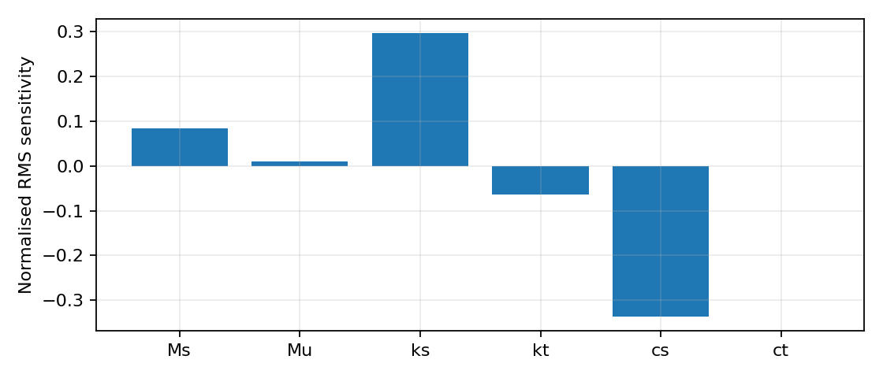
Figure 4. Normalised parameter sensitivity for body RMS displacement under the 0.5 s bump.
Suspension damping has the largest magnitude of sensitivity (−0.337), closely followed by spring stiffness (+0.297). Increasing damping or reducing stiffness therefore lowers the body RMS displacement in this particular study. Tyre damping is almost insensitive at its very small assigned value. This ranking concerns body displacement, the selected interval and this road waveform; it does not rank sensitivity for every ride or handling objective.
Reducing ks by 20% lowers acceleration RMS from 0.3802 to 0.3159 m/s², while increasing cs by 20% lowers it to 0.3713 m/s². Nevertheless, higher damping increases peak dynamic tyre load in this test, from 610.1 to 635.2 N. Stiffness and damping must therefore be considered together. Mass changes are included for diagnosis; they are not proposed as practical tuning actions.
Changing road amplitude alone would trivially reduce all linear responses, without improving the vehicle. The design recommendation instead keeps the assigned 30 mm height fixed. Abd-Elwahab et al. (2024) similarly motivate assessment of both stiffness and damping, but their numerical optimum is not transferred to the present individual model.

9 Effect of the modified design
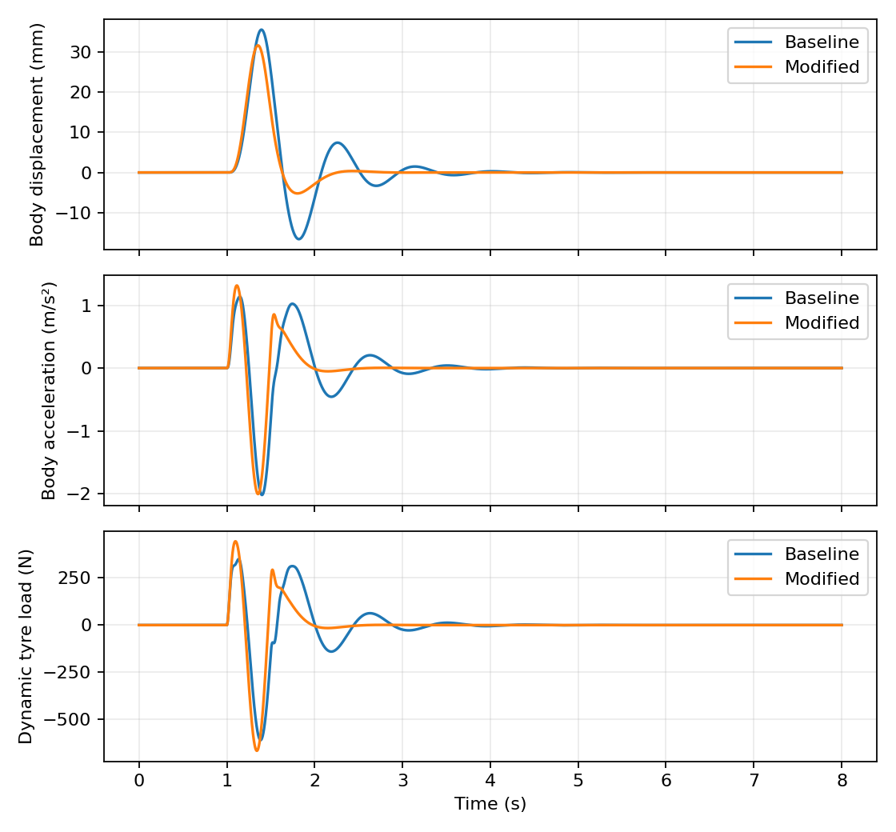
Figure 5. Baseline and modified road-only responses under identical bump excitation.
The modified suspension suppresses the slower body oscillation and reduces relative suspension motion. The increase in damping transfers more velocity-dependent force between wheel and body; its effect cannot be judged solely by the smaller displacement trace. The peak wheel displacement and dynamic tyre load both increase.
A conservative contact check gives Fz ≥ 3404.07 − 666.60 = 2737.47 N for the modified road-only case, so this linear simulation does not predict tyre lift-off. This bound uses the maximum absolute load fluctuation; it is not a measured minimum contact force. Full braking, cornering and transient load-transfer performance remain outside this vertical model.
The direct static suspension sag rises from 168.78 to 241.12 mm as the spring softens. That increase of 72.33 mm is a significant packaging concern despite the reduced dynamic travel. Available jounce, ride height, preload and suspension motion ratio must be established before adopting the modified stiffness. The selected 250 mm sag constraint only limits this numerical study.

10 Road duration and frequency checks
Bump duration | Body RMS baseline to modified mm | Acceleration RMS baseline to modified m/s²
0.25 s | 4.152 → 3.346 | 0.3657 → 0.5093
0.50 s | 7.148 → 5.618 | 0.3802 → 0.3390
1.00 s | 9.423 → 8.138 | 0.2809 → 0.1871
Shortening the bump to 0.25 s increases its rate of change. Although body RMS displacement falls by 19.4%, acceleration RMS increases by 39.3% and peak absolute dynamic tyre load rises from 926.8 to 1465.6 N. The modified design therefore fails the original acceleration and tyre-load acceptance conditions for this shorter bump. A 1 s bump improves both displacement and acceleration measures.
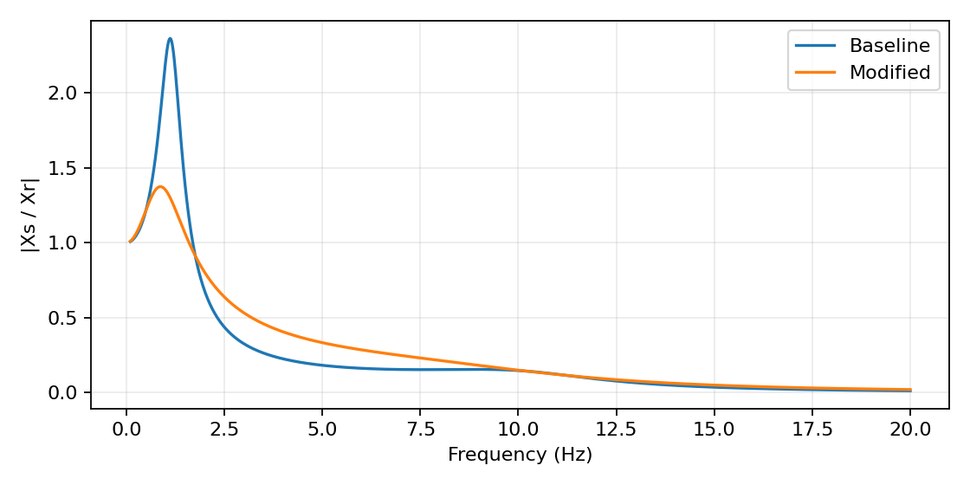
Figure 6. Body displacement transmissibility calculated from the harmonic dynamic stiffness matrix.
The frequency response is computed from [K − ω²M + iωC]Q = [0, kt + iωct]ᵀXr. It explains why the response depends on excitation frequency: changing spring and damping reshapes the gain across the spectrum. The zero-frequency gain tends to one for both designs. Reducing travel over one bump is therefore insufficient evidence of improvement across all roads.
A robust extension would retain the same design over repeated bumps, multiple vehicle speeds and measured rough-road profiles. Passenger comfort should then be evaluated with suitable frequency weighting and realistic exposure duration, as considered by Nagarkar et al. (2024). No comfort category is assigned to the present unweighted transient results.

11 Discussion and conclusion

Discussion
The assigned system has well-separated body and wheel-hop modes. Free-response energy decays, and the road response shows the expected distinction between rapid wheel movement and slower body oscillation. The combined case demonstrates why initial conditions matter: its body peak differs from the road-only peak even though the physical parameters and bump are identical. Keeping those cases separate makes the design comparison interpretable.
For the tested 0.5 s bump, increased damping is the most sensitive parameter for reducing body displacement RMS, with stiffness close behind. The modified design improves body displacement, acceleration RMS and suspension travel, but increases dynamic tyre load and static sag. This is a compromise rather than an unqualified comfort improvement. The shorter-bump result is particularly important because it reveals a failure that the original displacement objective would otherwise conceal.
The two-degree-of-freedom linear model omits nonlinear damper characteristics, friction, bump stops, tyre enveloping, suspension geometry and body flexibility. It also cannot assess pitch, roll, lateral handling or crash safety. Road duration and initial velocity were not supplied, so the selected assumptions materially affect the results. Literature on nonlinear characteristics (Ozcan et al., 2023) and physical implementation (He et al., 2023) supports validating these simplifications before practical design decisions.
Further work should confirm the intended interpretation of Xs, Xu and xr with the module tutor, run the supplied code in MATLAB, measure the available suspension stroke, and validate the model against a quarter-car rig. A broader multi-objective search should include several road durations and explicit tyre-force, weighted-acceleration and static-load constraints. Comparisons must use the same initial conditions, road input and evaluation interval.

Conclusion
The passive suspension for SRN 23103907 was derived from force balance and solved as a coupled system. The undamped natural frequencies are 1.157 Hz and 10.680 Hz. The assigned offsets produce a decaying free response, while the assumed 30 mm bump excites both wheel and body motion. Under a 0.5 s bump from rest, changing ks to 12,340.02 N/m and cs to 2,623.4 Ns/m reduces body RMS displacement by 21.4% and acceleration RMS by 10.8%. Damping is the most sensitive parameter for this displacement objective. Increased static sag and poorer acceleration on the 0.25 s bump prevent a general recommendation. The modified design is a candidate for further validation under the stated conditions.

References
Abd-Elwahab, M.R., Makrahy, M.M., Ghazaly, N.M. and Moaaz, A.O. (2024) “Optimization and Analysis of the Quarter Car Passive Suspension Using Taguchi, Genetic Algorithm, and Simulated Annealing Approaches”, International Journal of Transport Development and Integration, 8(3), pp. 383–392. https://doi.org/10.18280/ijtdi.080302.
He, H., Li, Y., Clare, L.R., Jiang, J.Z., Al Sakka, M., Dhaens, M., Burrow, S.G., Neild, S.A. and Conn, A.T. (2023) “A configuration-optimisation method for passive-active-combined suspension design”, International Journal of Mechanical Sciences, 258, 108560. https://doi.org/10.1016/j.ijmecsci.2023.108560.
Mudduluru, S.R. and Chizari, M. (2021) “Quarter and Full Car Models Optimisation of Passive and Active Suspension System Using Genetic Algorithm”, arXiv preprint. https://doi.org/10.48550/arXiv.2101.12629.
Nagarkar, M., Bhalerao, Y., Sashikumar, S., Hase, V., Navthar, R., Zaware, R., Thakur, A., Wable, A., Ashtekar, J. and Surner, N. (2024) “Multi-objective optimization and experimental investigation of quarter car suspension system”, International Journal of Dynamics and Control, 12(5), pp. 1222–1238. https://doi.org/10.1007/s40435-023-01262-x.
Ozcan, D., Sonmez, U., Guvenc, L., Ersolmaz, S.S. and Eyol, I.Y. (2023) “Optimisation of Nonlinear Spring and Damper Characteristics for Vehicle Ride and Handling Improvement”, arXiv preprint. https://arxiv.org/abs/2306.08222. The year refers to the arXiv posting.
University of Hertfordshire (2025a) Quarter Car Model Assignment Briefing. Module 7ENT2056. Coursework brief supplied as screenshots.
University of Hertfordshire (2025b) 7ENT2056-7AAD0054 Class list Quarter Car Assignment 2025. Individual parameter row for SRN 23103907.
OpenAI (2026) ChatGPT. AI assistance used on 7 October 2026. https://chatgpt.com/.

Accompanying MATLAB implementation
Quarter_Car_23103907.m contains the individual parameters, force-based state model, modal calculation, free and combined cases, sensitivity study, 144-point constrained grid, duration tests and frequency-response plots. Run the complete script in MATLAB and review the resulting figures and table outputs before submission. It also exports a CSV of the combined-response time history.

